Phone No: 0194-2310144/2310060
Fax: : 0194-2310144


OFFICE OF THE PRINCIPAL,
KASHMIR GOVT. POLYTECHNIC COLLEGE GOGJI BAGH SRINAGAR.
http://www.kgpsrinagar.edu.in.
Email: kgpolysgr58@gmail.com
M/S Unique Book Media, Srinagar.

No: KGP/Estt/2025/1239-1240 Dated:04-10-2025

Subject: Supply order for Books.

Sir/Madam,
Your Discount rates on Books have been approved by the market Survey committee. You are as such requested to supply the below-mentioned books to this institution within five days from the date of this supply order. The Bill of cost shall be sent in triplicate for pass and payment. The payment shall be made after receipt of the books. The rates shall be inclusive of GST and any other charges. The rates are FOR Kashmir Govt. Polytechnic College Srinagar.

S.No | Name of the Book | Qty Required
1 | Language and Communication Skills-Sharanjeet Kaur | 150

Yours Sincerely
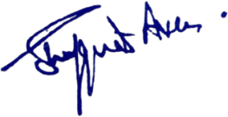
Principal
Kashmir Government Polytechnic College
Srinagar

Copy to the:
1. Library Section for information and necessary action.

